UNIT 6 WEBSITE DEVELOPMENT

Assignment 6.2 - Design and develop a website for client requirements.

Kian Forghani-Ashrafi

**Contents**

Introduction

Problem definition, Client Requirements and Target Audience

Benefits, constraints, and ethics

Legislation

First email to client

Homepage Design 1

Homepage Design 2

Design Questionnaire and feedback.

Site Map

Five Page Design Storyboard/Wireframe

Mobile layout design

Justify Design Choices (Explain how they fulfil purpose and User needs)

Asset List/Table

Common tools and techniques used.

Documentation of Website

Flowchart Diagram and CSS (Cascading Style Sheets,)

Test Plan (Including images)

Website Testing (X3 Web browsers on PC and on Phone)

Website Questionnaire and feedback

Witness Statement

Before & After Errors (X3 Design and X2 code changes)

Website Optimization

Evaluate the design and optimized website against client requirements.

Second email to client

Project Timeline/Table

Evaluation of Website against the Client Requirements

Technical Documentation

Bibliography

**Introduction**

For assignment 6.2, I need to create designs for a new section of Hot Beans Web website so they can recruit more web developers. The assignment is asking me to create a profile for the company, create profiles of existing trainee web developers, create job specifications, and require qualifications, an online application form, and links to web development courses. I’ll be using scripting languages such as Hypertext Markup Language (HTML), Cascading Style Sheets, (CSS), and JavaScript. To ensure that my website works, I need to test and review the website on different web browsers and devices. I will also need to gather information about user requirements using SQIRO and then evaluate and optimize the website against client requirements.

Project Timeline/Table

|  |  |  |  |
| --- | --- | --- | --- |
| Task Number | Dates | Task | Achieved Not Achieved |
| 1 | 28/02/2022 | Start date | YES |
| 2 | 28/02/2022 | Produce a Task List |  |
| 3 | 02/03/2022 | Produce 2 designs for the client |  |
| 4 | 02/03/2022 | Have an interview with the client |  |
| 5 | 10/03/2022 | Complete the Design stage |  |
| 6 | 10/03/2022 | Create a Site map |  |
| 7 | 14/03/2022 | Gather images and text for website |  |
| 8 | 19/03/2022 | Develop Home page |  |
| 9 | 21/03/2022 | Develop Employees page |  |
| 10 | 23/03/2022 | Develop Work for Us page |  |
| 11 | 24/03/2022 | Develop Careers page |  |
| 12 | 30/03/2022 | Develop Useful Links page |  |
| 13 | 31/03/2022 | Make Terms and Conditions |  |
| 14 | 20/04/2022 | Test Website on different browsers |  |
| 15 | 20/04/2022 | Test Website on different devices |  |
| 16 | 26/04/2022 | Carry out Website Evaluation |  |
| 17 | 29/04/2022 | Hand in date |  |

**Problem definition, Client Requirements and Target Audience**

Before creating and building a website, the website developer needs to make sure they bring out as much information from the client. When a website developer has more information about clients’ requirements, they can fulfill the requirements with more effectiveness. All the information about the requirements for a website will be collected with a problem definition statement. A common method to gather information about the requirements is called SQIRO. This stands for sampling, questionnaires, interviews, research, and observations. A website developer uses these techniques with the client to get as much information as possible, so they can fully understand the problem that the website is intended to solve. The target audience is the people who have completed training courses/qualifications related to web development and are now looking for a job as a web developer.

**Benefits, constraints, and ethics**

The benefits for a business having a website includes being able to advertise their products/services worldwide. Advertising on a website is less expensive than printed media, radio, and television advertising. It’s also accessible 24/7 anywhere where there’s an internet connection. Other websites can link to you, which increases the businesses customers and audience and spreads the word about the business’s product and services. Furthermore, having a website means that you can develop long term clients. These are customers who visit your website regularly which helps the business grow. The constraints are the limitations a website could have which makes it difficult to design and develop. For example, constrains on a website is money, timescales, staff training, levels of security and support and maintenance contracts. When developing and designing websites, there are two types of constraints: technical and design constraints. Technical constraints include IT staff and IT equipment. IT staff is where the skills needed isn’t available for the creation of the website. This means staff would need to be trained first to complete the design and development of the website. IT equipment is when the website might need specialised hardware or software that need to be bought or installed before the website can be designed and developed.

**Legislation**

**Copyright, Designs, and Patents Act 1998**

This protects original works such as music, art, writing, and programming code once it’s tangible, which means once it’s in its fixed form. For example, when a book is published or when a music album is released. These original works are the property of the individuals who created them. Websites are now protected under copyright law, meaning a website becomes tangible once it's coded and saved onto storage media.

**Data Protection A****ct 1998**

The Data Protection Act 1998 is designed to protect sensitive data held in databases. Businesses that store data about customers' information must register and state the data they want to hold. A website developer needs to consider how the data protection act affects their business. For example, a website that collects users’ data, such as an enquiry form asking for personal information, should include a privacy policy which informs website visitors how you retain, process, and disclose their data in line with the legislation. Principles of the data protection act 1998 include; to not keep personal data longer than necessary, process personal data fairly and lawfully, ensure that the personal data is accurate and kept up to date, only collect/process personal data if there is a legitimate reason to do so, to not transfer personal data to countries outside the EEA unless there is adequate protection, to take technical and organizational measures against the hacking or loss of personal data and to preserve the rights of the data you hold for individuals.

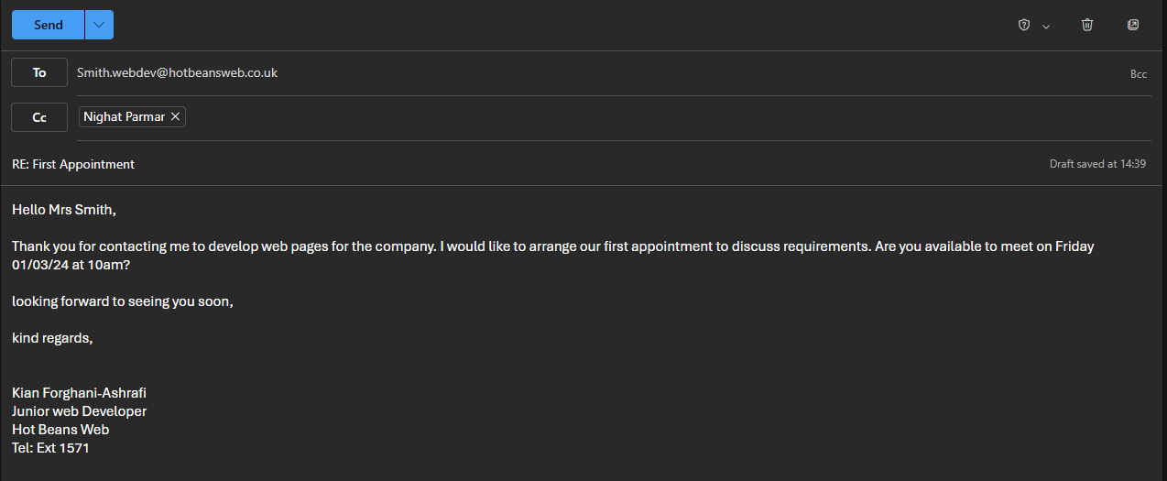**First email to client**

**Homepage Design 1**

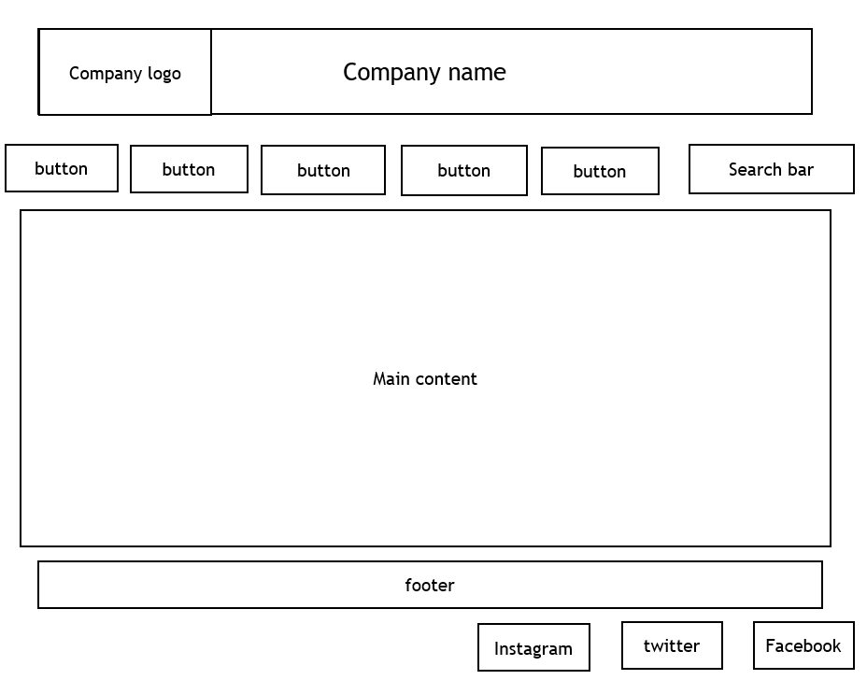

**Homepage Design 2**

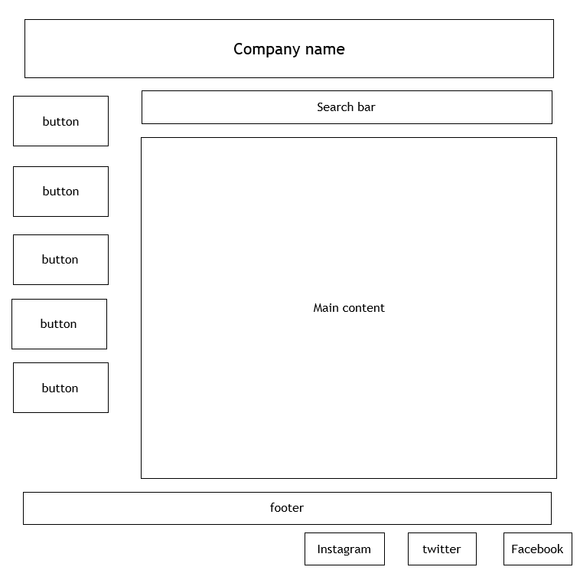

**Design Questionnaire and feedback.**

1. What are the basic requirements you would like on your website?

Navigation buttons, logo, images, text content, search bar, social media icons

1. How would you prefer hyperlinks to be applied to the website?

I would prefer hyperlinks to be applied to the navigation buttons and the social media sites.

1. Who is your target audience on your website?

people who have completed training courses/qualifications related to web development and are now looking for a job as a web developer.

1. What are your goals for this web project?

To design a responsive website for hot beans web

1. Do you prefer homepage design 1 or 2 or neither?
2. If neither, what changes would you like me to include?

Homepage design 1

1. On a scale of 1-10 how would you rate the layout you selected (1 being bad 10 being very good)

10

1. How would you prefer your images to be positioned on your website (centre of the page, left side? right side?)

Left side.

1. Do you require the end user to attach a pdf file or other documents?

No

1. On a scale of 1-10, how would you rate the colour scheme you selected? (1 being bad 10 being very good)

10

10. How is the website you created user-friendly?

It has a responsive design as it can be used properly on pc and mobile devices. It has an effective navigation where users can navigate through different web pages using the headers. The website also includes a search bar so users can search for content easily.

**Site Map**

Home Page

Index.html

Company Profile

Company.html

Work For Us

Work.html

Employees

Employees.html

Useful Links

Links.html

Careers

Careers.html

Job Specifications

Required Qualifications

**Five Page Design Storyboard/Wireframe**

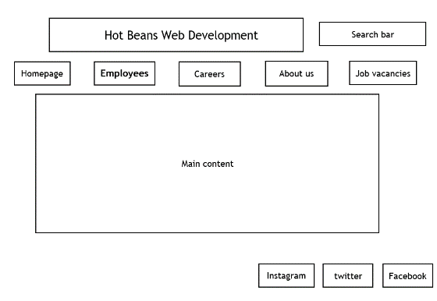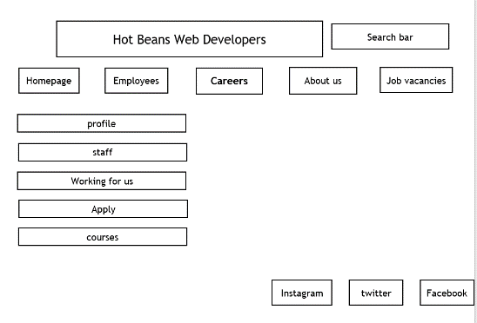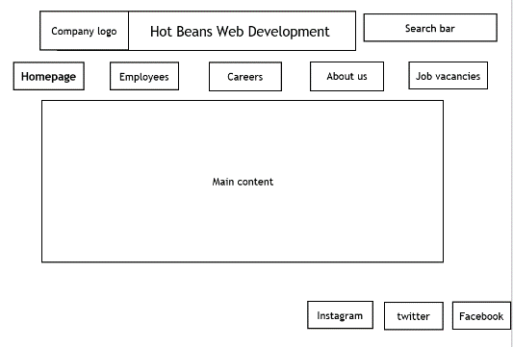

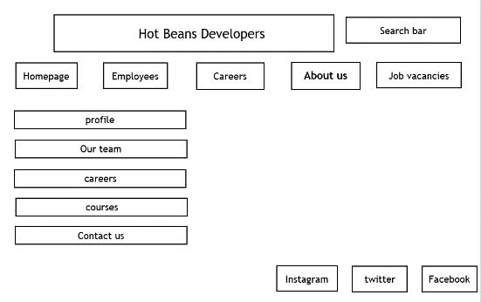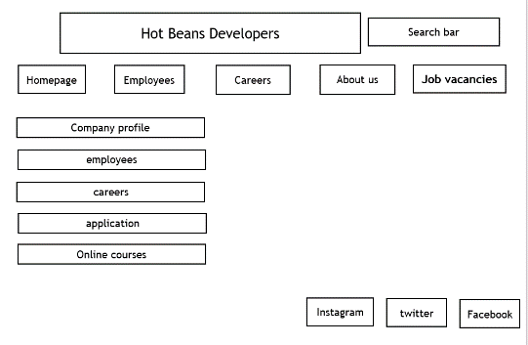

**Font**- I used trebucket font size 12 for the action buttons and main text, and I made the font bold for the headings.

**Navigation**- I added buttons/hyperlinks at the top of the page, leading the user to different web pages. This includes the homepage, employees, careers, and job vacancies. I also added buttons at the bottom of the page leading users to the company’s different social media accounts like Instagram, twitter, and Facebook.

**Layout**- I added a banner at the top of the page representing the company’s name with their logo on the left-hand side. I added a search bar on the top right-hand side with buttons leading to different web pages underneath the banner. The main information will be presented in the middle with different social media links on the bottom right.

**Main content**- I used different images, text and information on the website making it more visually appealing for users.

**Color**- I used a white background with black text.

**Mobile layout design**

Hot Beans Web Development

Search bar

Employees

About us

Careers

**Homepage**

Job vacancies

Main content

Instagram

Facebook

twitter

**Font**- I used a trebuchet MS size 14 for the company name and trebuchet MS size 8 for the buttons and hyperlinks size 12.

**Navigation**- the mobile layout has buttons at the top of the page leading users to different web pages. This includes the homepage, employee, careers, and job vacancies. The mobile layout has a search bar at the top right, making it easier to navigate through the website. There are also buttons on the bottom right leading users to the company’s social media such as Instagram, twitter, Facebook.

**Layout**- I added a banner at the top of the page representing the company’s name. I added buttons underneath the banner which leads the user to different web pages. I added a search bar to the top right so users can find information easily. The main information is presented in the middle with different social media links located on the bottom right.

**Main content**- I added information and text and different images om the website making it more visually appealing for users.

**Color**- I used a white background with black text.

**Justify Design Choices (Explain how they fulfil purpose and User needs)**

All the web pages are easy to navigate as they have buttons near the top of every page leading to different web pages. Also, they have headings making it easy for users to know what page they are on. Each web page has a search bar placed at the top right, so it’s easy for website users to find information efficiently. For all the pages, the font size is 12 making the information easily readable. The font color is black, so the information stands out, and users can easily read the content. The background will be white, creating a nice contrast between the text and background, making the information easy to read. By having a white background, it maintains consistency throughout the website, making it look clean and professional. The company logo will be placed at the top, above the company name, so it’s clear for users to know what website they are on. I’ve also added an application form with a submit button so users can submit their applications easily. I’ve made sure to create an alternative design so the client can choose which one they prefer. By doing this, it helped me create the final design that meets the client requirements.

I first designed the homepage where the company name and logo were at the top with the navigation buttons and the main content being in the middle of the page. I then designed another version of the homepage where the company name was at the top with the search bar and the navigation buttons placed on the left-hand side. Both designs meet the client requirements however I’ll be using design one as it meets the client requirements better and has a more aesthetic look. For the mobile design, the design didn’t fit the page, making it unesthetic. The text didn’t fit the page, and the company name was too big. So, to improve this, I made the font smaller on mobile devices, so the design fits the screen size, making it easily readable and useable.

**Asset List/Table**

|  |  |  |  |
| --- | --- | --- | --- |
| image | File name/ file type | location | Predefined code |
|  | Microsoft word document | All pages | <img src="../../../../../Picture1.png" width="169" height="133" alt=""/> |
| Download Facebook, Facebook Logo, Facebook Icon. Royalty-Free Vector  Graphic - Pixabay | .GIF file | All pages | <img src="https://cdn.pixabay.com/photo/2017/06/22/06/22/facebook-2429746_640.png" alt="Download Facebook, Facebook Logo, Facebook Icon. Royalty-Free Vector Graphic - Pixabay"/> |
| Submit Button" Images – Browse 273 Stock Photos, Vectors, and Video | Adobe  Stock | JPG file | Careers page | <img src="https://t4.ftcdn.net/jpg/05/49/08/97/360_F_549089774_Tq2jr6XW7IdmbzbPxiNHRXUyBJtGSTmz.jpg" alt="Submit Button' Images – Browse 273 Stock Photos, Vectors, and Video | Adobe Stock"/> |
| Instagram Logo - Free Vectors & PSDs to Download | JPEG file | All pages | <img src="https://upload.wikimedia.org/wikipedia/commons/thumb/e/e7/Instagram_logo_2016.svg/2048px-Instagram_logo_2016.svg.png" alt="File:Instagram logo 2016.svg - Wikimedia Commons"/> |
| Twitter Logo - Free Vectors & PSDs to Download | .GIF file | All pages | <img src="https://img.freepik.com/free-vector/new-2023-twitter-logo-x-icon-design_1017-45418.jpg?size=338&ext=jpg&ga=GA1.1.1700460183.1713139200&semt=ais" alt="Twitter Logo - Free Vectors & PSDs to Download"/> |
| How a Hybrid Workforce Benefits Employers and Employees - FlexJobs | JPEG file | Employees page |  |
| Foursquare moving from Google Maps to OpenStreetMap - Life |  siliconrepublic.com - Ireland's Technology News Service | JPEG file | All pages except homepage |  |

An assets table represents all the digital assets on a website. These assets include images, videos, audio files, text content, databases, and JavaScript files. An asset table can help a website developer organize and manage their digital assets that’s needed for the website. It also helps them optimize their website performance asset tables that can include file size, dimensions, and format. This means they can identify files or assets that can slow down the website. The assets that I’ve used are mostly ready-made assets; however, I used an original asset for the company logo.

**Common tools and techniques used.**

**HTML** (Hypertext Mark-up Language) is the main mark-up language. It uses a system of tags (< >) which contain instructions. These instructions come in a pair of open and closed tags enclosing the content to be affected. For example, <font colour= “red”>Some text</font> would produce ‘Some text’. I’ve used HTML for the layout of my website such as the heading, subheadings, images, and tables. **HTML5** is the current hypertext mark-up language standard used for structuring and presenting content on the worldwide web. I've used HTML5 for my website as it doesn't use tags to change the font but instead uses CSS.

I've used **Tables** on my website to present tables on each page. Each page has a section on the left-hand side so users can find more information. For example, I've used tables for the application form so each subheading is sectioned out, and so users can fill in their information. Tables help make the website neat and look aesthetic.

**Forms** are used in website development to collect user input. There are different ways of collecting user input using forms; text field, text area and submit button.

**Text field – this defines a one-line input field for text input.**

<form>

Please enter your first name:<br>

<input type=“text” name=“firstname”><br>

**Text area – allows you to have more user input.**

<form>

<textarea name=“textarea”> Please enter your text here</textarea>

</form>

**Submit button – defines a button for submitting a form to a form handler.**

<form action=“test_page.php”>

Where were you born?: <br>

Radio buttons- let a user select one of a number of limited choices

<input type=“text” name=“birthplace”><br>

<input type=“submit” value=“submit”>

</form>

<form> Are you sure?

<input type=“radio” name=“validation” value=“yes” checked>YES<br>

<input type=“radio” name=“validation” value=“no” checked>NO </form>

I've added **forms** onto the application page to collect users' information when they want to apply for the jo. It also makes sure users don't miss out on any information. I've added a text field onto my website to make sure users add in their information. I've also added a submit button onto the form so users can submit their application.

I've used **Navigation** when creating my website so users can move around to find more information. I've made sure that each page is interactive so users can click onto different web pages. Furthermore, I've added in a search bar so users can navigate around the website more efficiently.

**Menus** – appears at the top of my web page. Allows users to change web pages e.g., home, employees, careers, about us and job vacancies.

**Hyperlinks** – are links that, when clicked on, take you to a particular part of the website (an internal link) or they will take you to another website (an external link). Hyperlinks can be text, images, or buttons. I used hyperlinks on my website so users can access hot beans web social medias e.g., Facebook, Instagram, and twitter.

**Anchors** – are used to redirect a user to a certain part of a web page.

**Interactive components** are used for enhancing the look and feel of a website. it requires input from the user which provokes a response from the computer. This could include giving feedback, searching a catalogue of products, or purchasing a product from a website. I’ve added a search bar so users can find what they are looking for faster and an application form so users can submit their details when applying for a role at hot beans web development.

**Hotspots** – is an area of an image that acts as a hyperlink. When a person clicks on a hot spot, a hyperlink takes the user to another web page. I’ve used social media icons at the bottom of my web pages, so users are directed to hot beans web social medias.

**Pop-ups** – these are small internet windows that pop-up on your screen to get a user’s attention.

**Buttons** – these look like command buttons. I’ve used buttons on my application page so users can submit their application.

**Rollover Images** – is a secondary image loaded on the web page to display when a user on the website rolls their mouse over a certain image. It is used to make the website more interactive.

**Color schemes, styles, and templates-** modern web designs use templates with built-in color schemes and styles. These templates are built using a technique called cascading style sheets (CSS). Cascading Style Sheets uses the same layout and style on all web pages, making the design easier to maintain. I used Cascading style sheets for my website to keep the design the same for all web pages. The background color on my website stayed the same throughout my website, and I kept the heading titles and the positioning of the same. The borders I used have the same layout on each page, and the font and its size are the same on each page. This is to make the website look professional and make the layout organized.

**Accessibility features-** Websites need accessibility features such as alternative tags which show text for an image. The alternative tags are read by screen readers and is useful for blind users as the screen reader tells the blind user what the image is zoom features are.

**Zoom features** are needed for the website, so people with poor vision can zoom in and out, making the content displayed larger or smaller for the user.

**Text-to-speech-** this is useful for visually impaired users. It’s a type of speech synthesis application used to create a spoken sound version of the text.

**The World Wide Web Consortium-** promotes the standards of web design such as HTML. It aims to ensure accessibility of the web. For example, they promote that all websites should be displayed on a variety of browsers so that they are usable for people with special needs. The guidelines of the world wide web consortium are to increase accessibly for all websites. HTML compliance is important because if we use outdated HTML coding techniques, it prevents websites from being fully accessible. In my website I've used HTML compliance, so the website is accessible to everyone.

**Embedded multimedia/digital asset content**

**Digital sound files-** There are different file types which have their own method of sampling and compression. A .Wav file has a high sample rate meaning the sound quality is close to the sound of actual instruments, however it has a large file size. A .MP3 file has a lower sample rate and therefore produces a smaller file size. Also, the quality of .MP3 is lower than .wav depending on the compression rate chosen.

**Digital video and animation files-** Video and animation files can affect the speed of a website and can produce large file sizes. Traditionally, users would have to click on a link and download it to view videos or animations. As the files would have been large, it would take a long time to download. However, HTML5 allows videos and animations to be embedded into web pages, which leads them to run more quickly.

**Platform compatibility-** I’ve made sure that my website works on different web browsers, operating systems, and mobile devices to meet client requirements. I will test my website, so they have the same appearance across different platforms.

**Exporting and Compression of digital assets-** compression is making a file smaller so that it uses less disc space. I’ve made sure the assets I’ve used have small file types, so my website will load faster. Having a faster download time makes my website user friendly. I’ve used bitmap file types on my website such as .gif and .jpeg. I’ve used .gif file for assets such as the Facebook and twitter logo as they don’t contain that many shades of colors. I’ve used .jpeg file for assets such as the image of employees, map, Instagram logo and submit button as they have a larger color palette and have a high-quality color image. I’ve saved these files and will export these digital assets to my website.

**Documentation of Website**

**homepage**

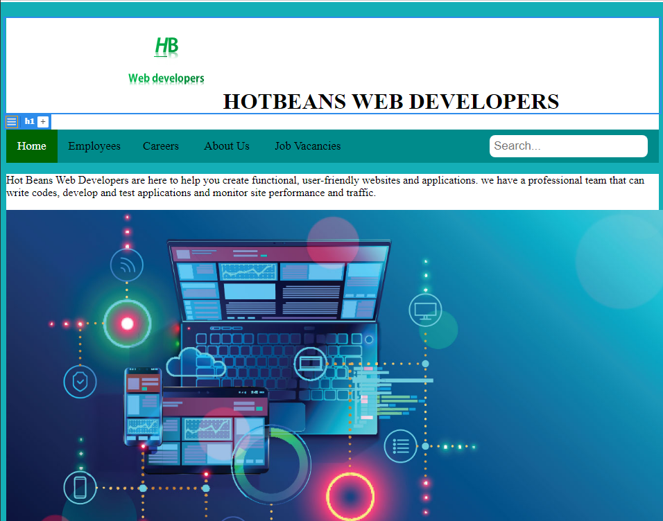

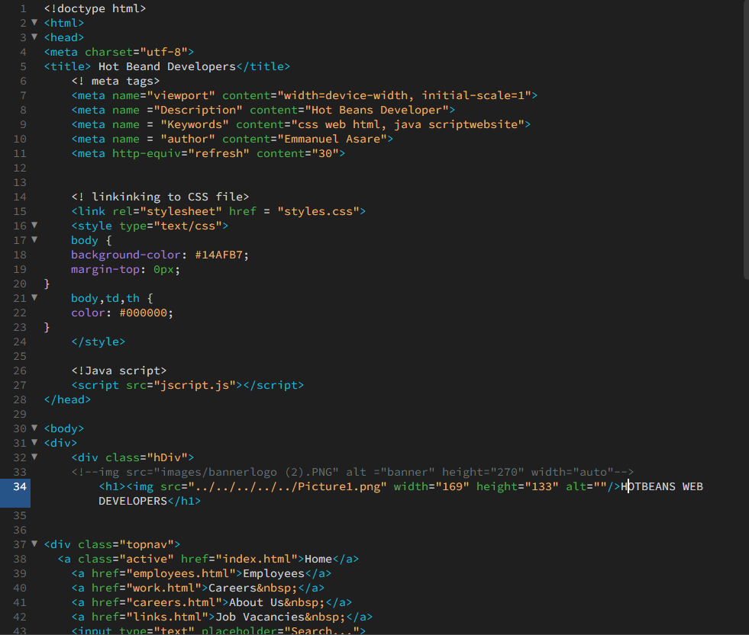

This screenshot shows the first page of my website, homepage, and its code

**Employees Page**

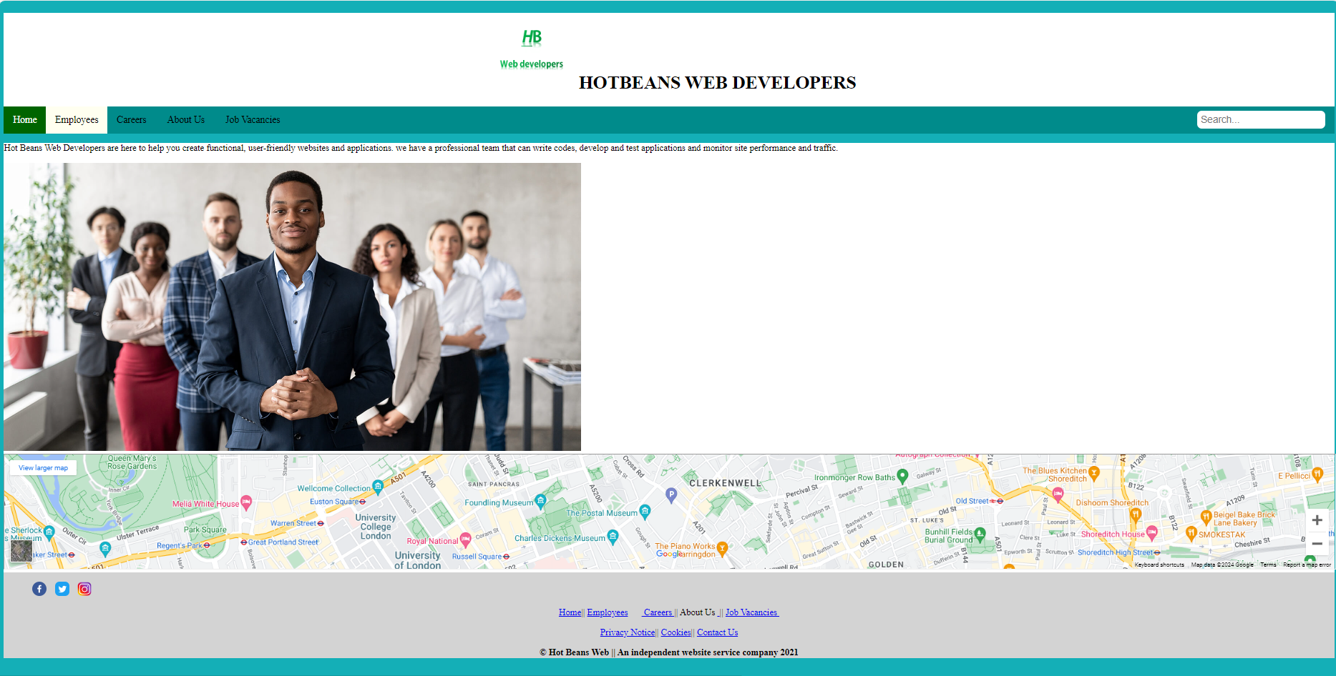

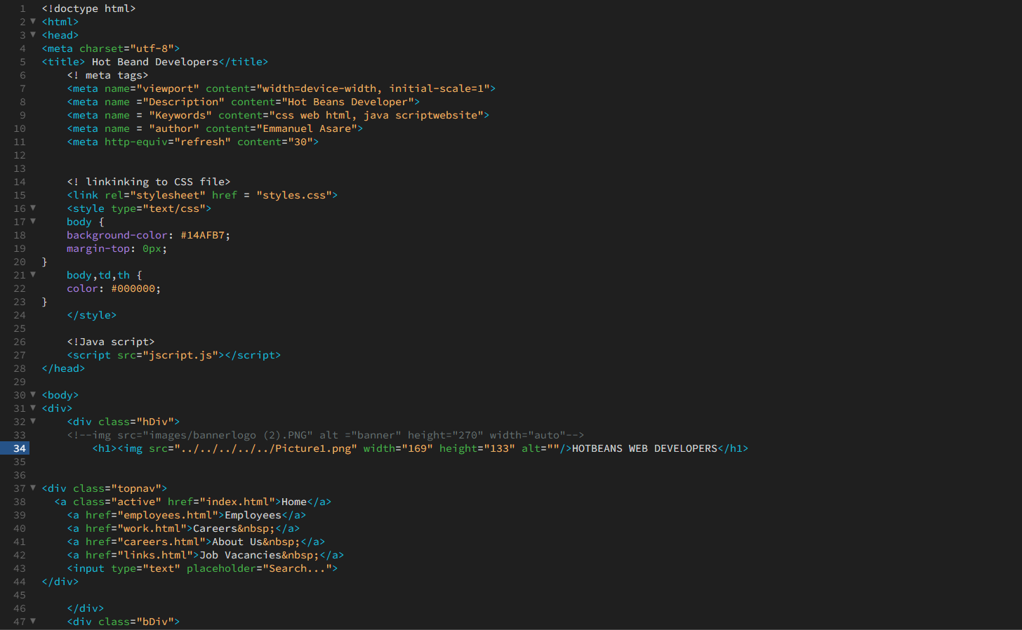

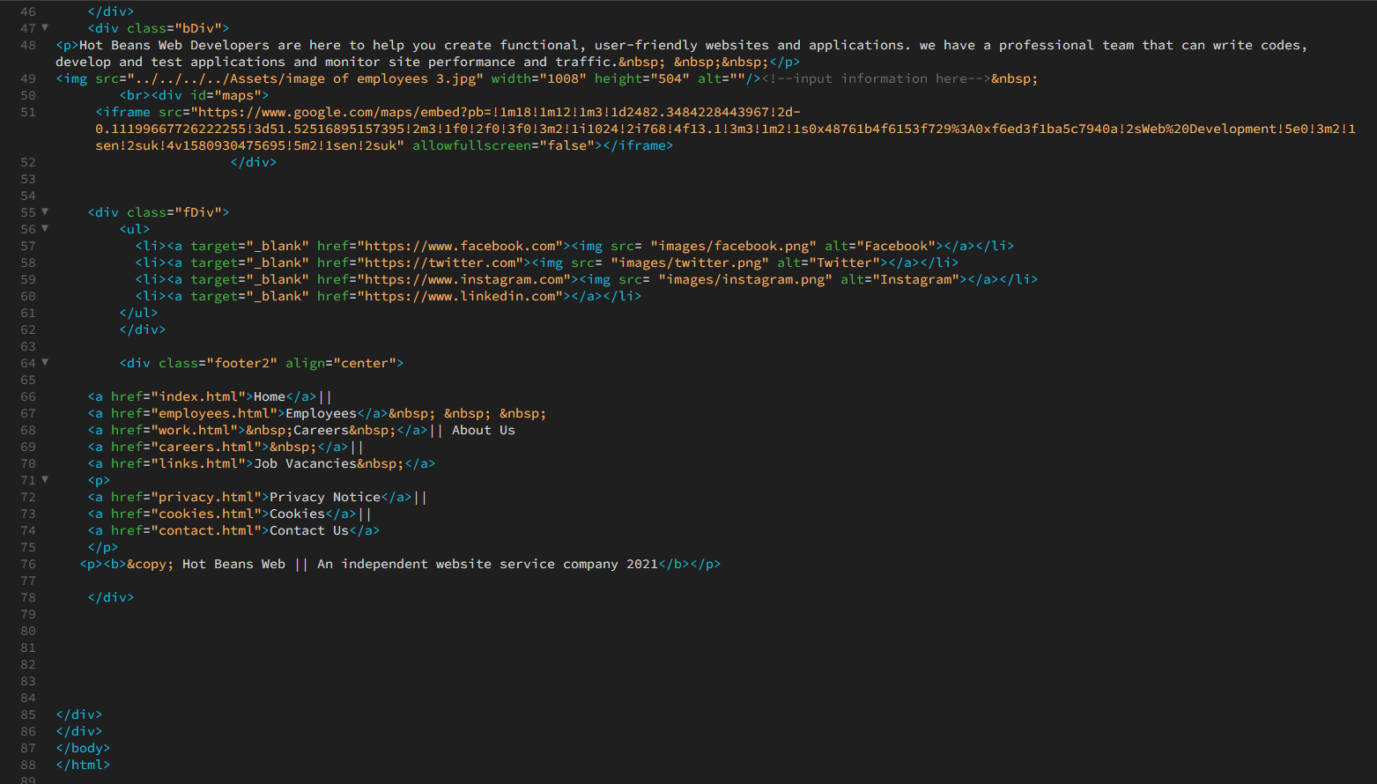

this screenshot shows the employees that work for hot beans web and the code used for the development of the page

**Careers page**

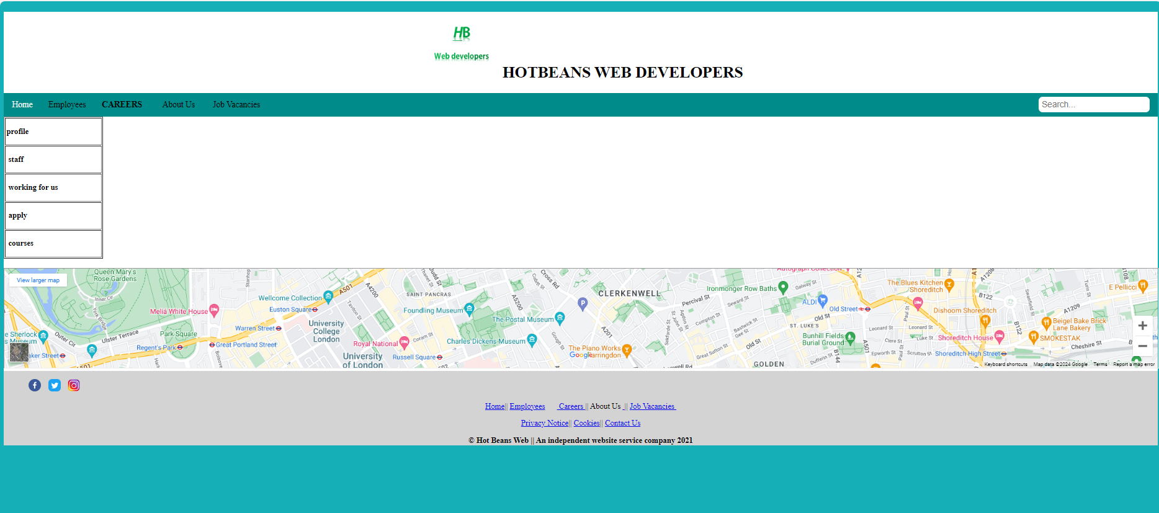

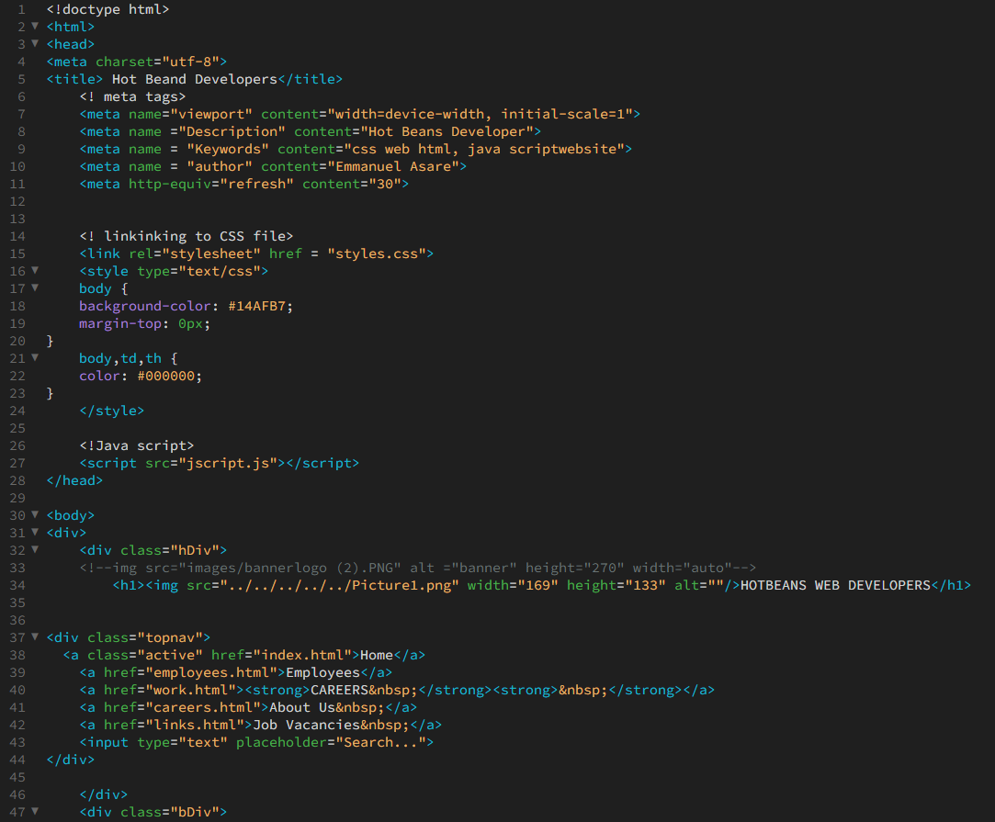

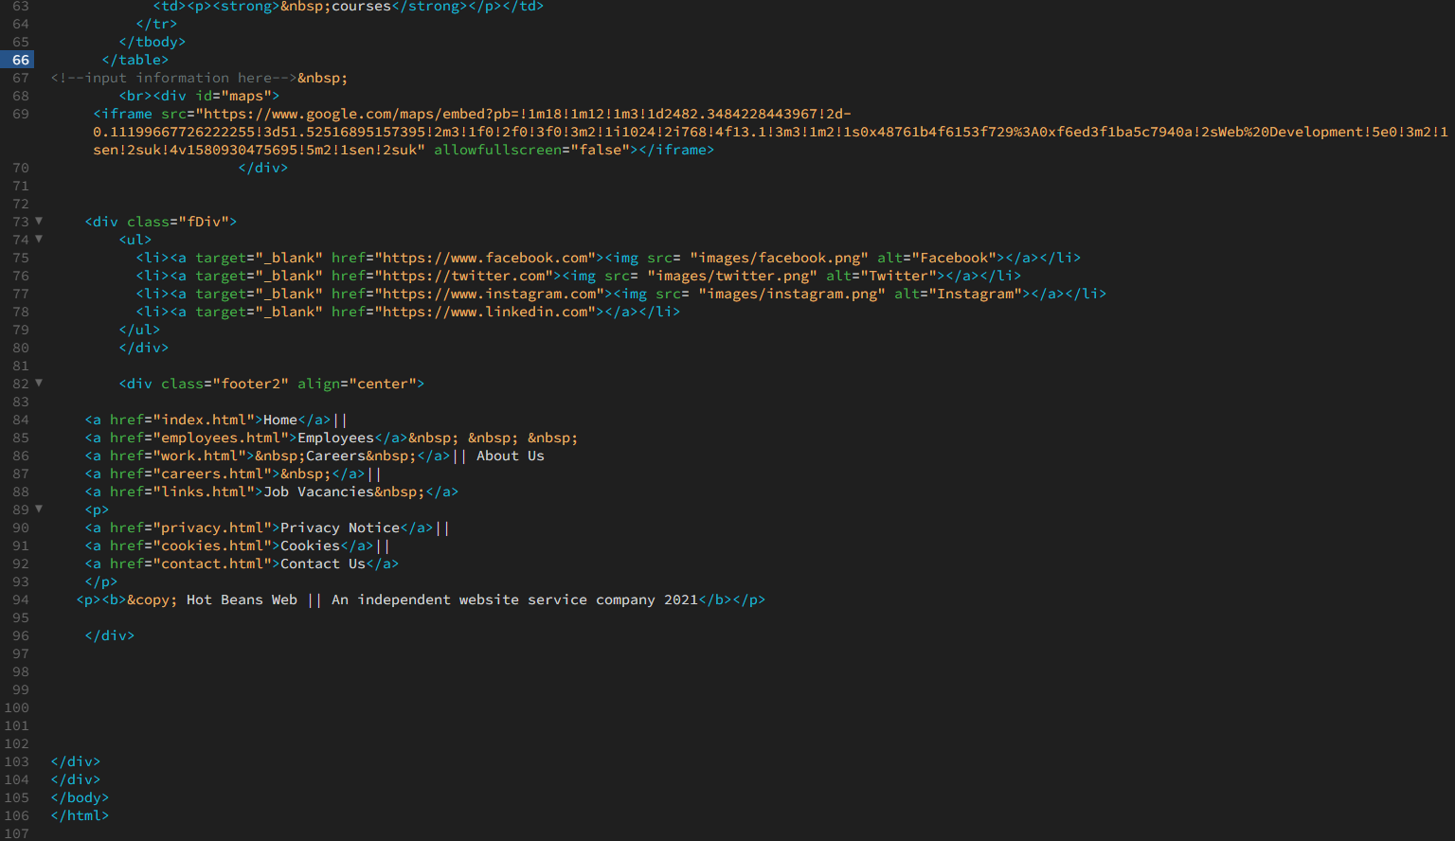

This screenshot shows the careers page of my website and the code used to create the page

**About us page**

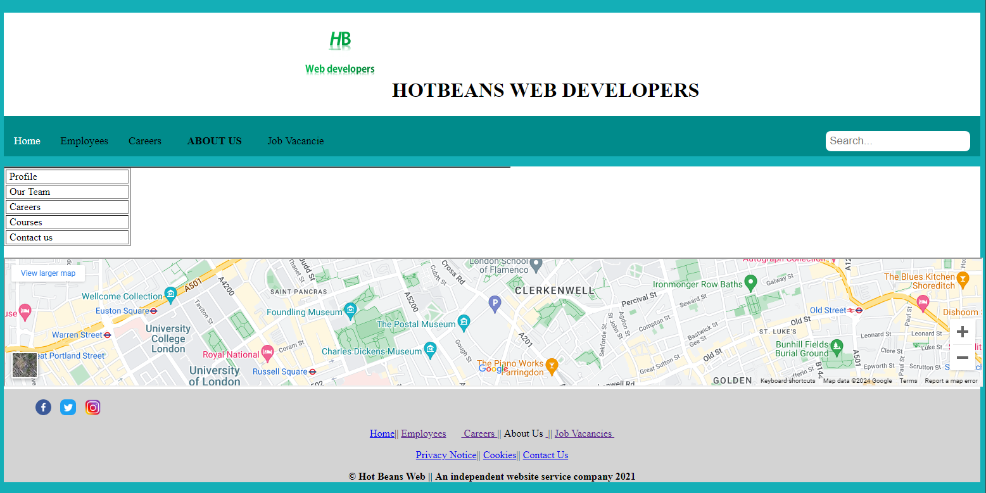

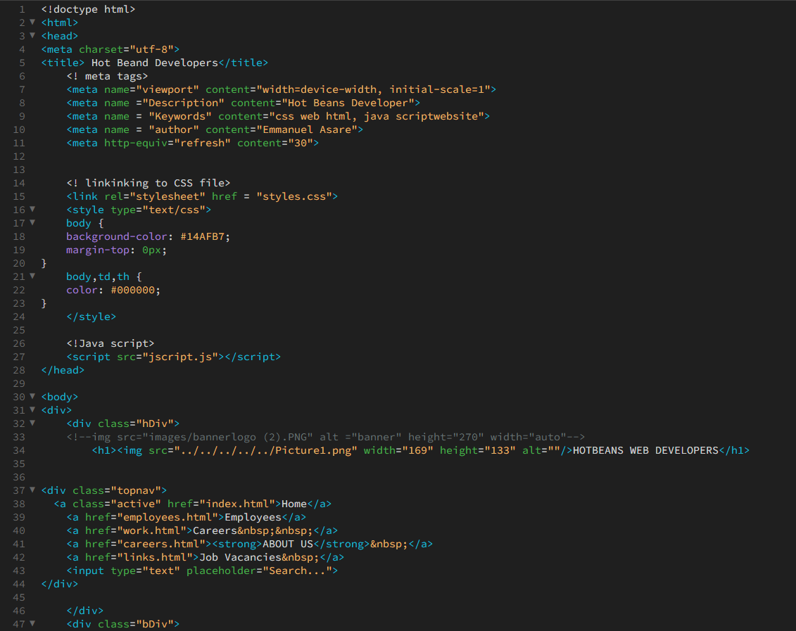

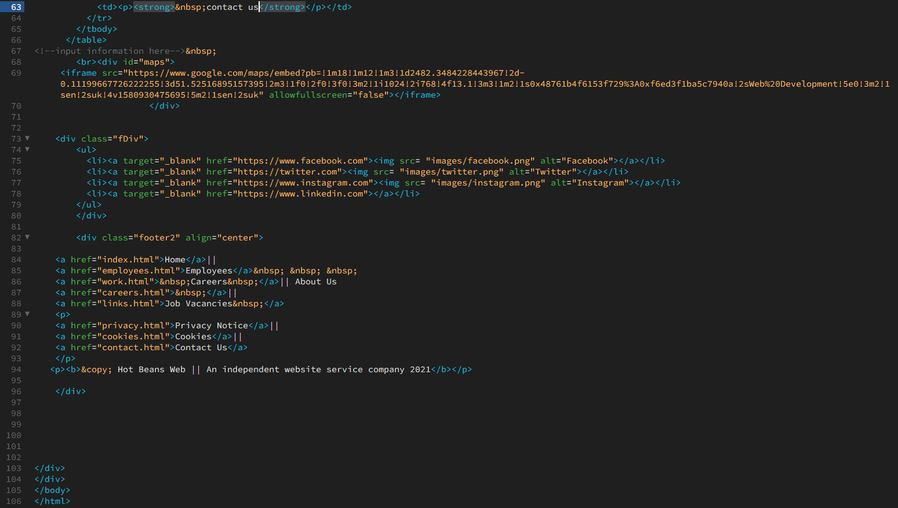

This screenshot shows the about us page and the code used to create the page

**Job vacancies page**

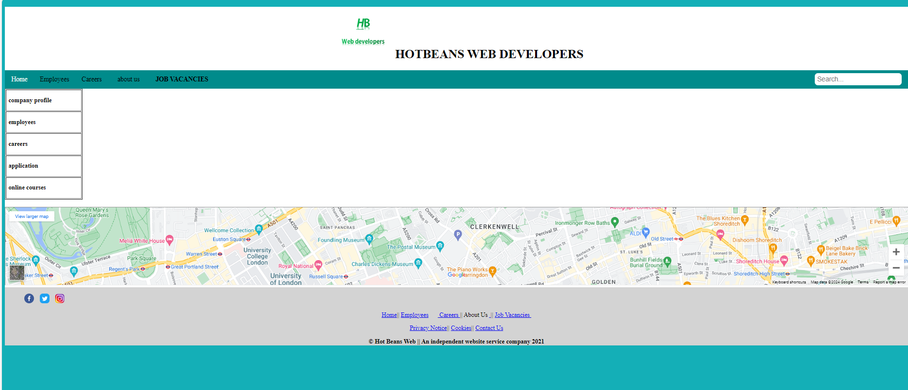

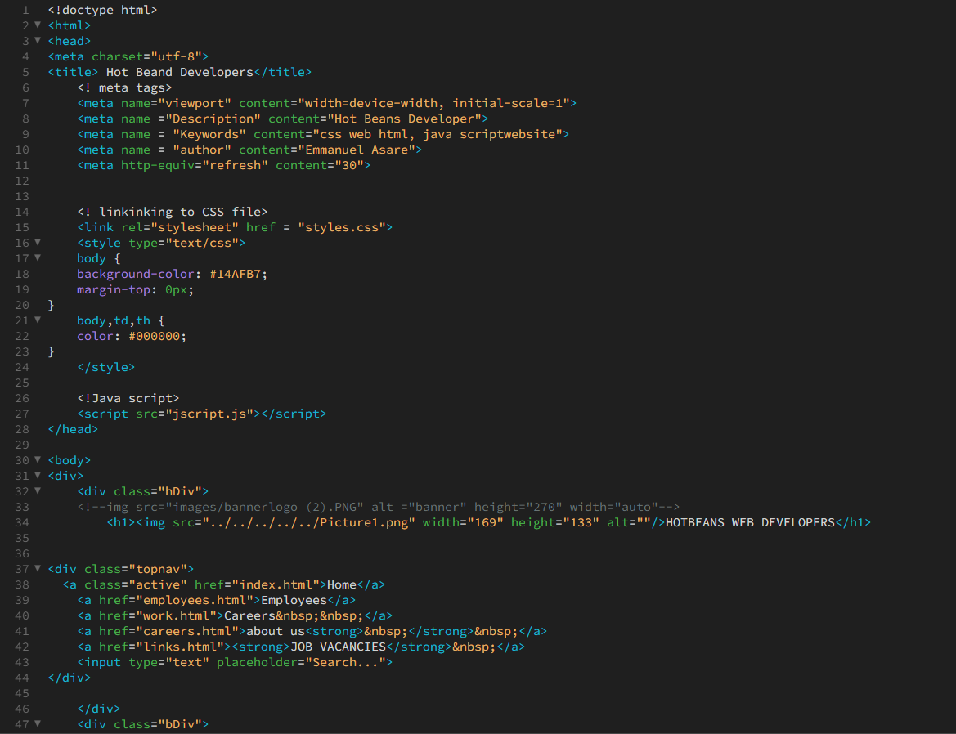

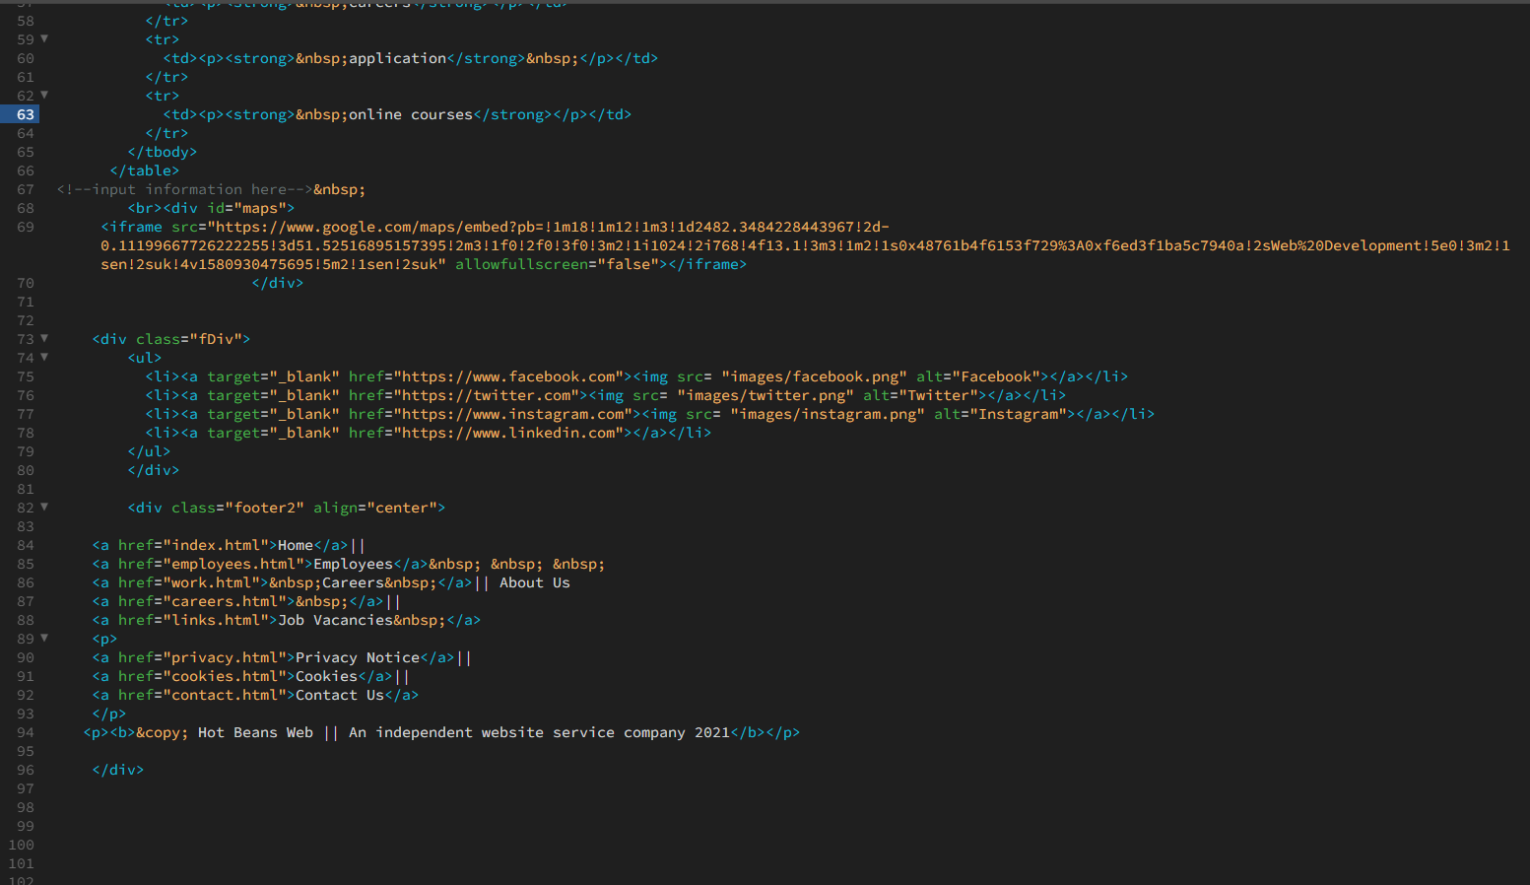

These screenshots show the job vacancies page so people can apply for a job at hot beans web development. It also shows the code used to create the web page

**Application form**

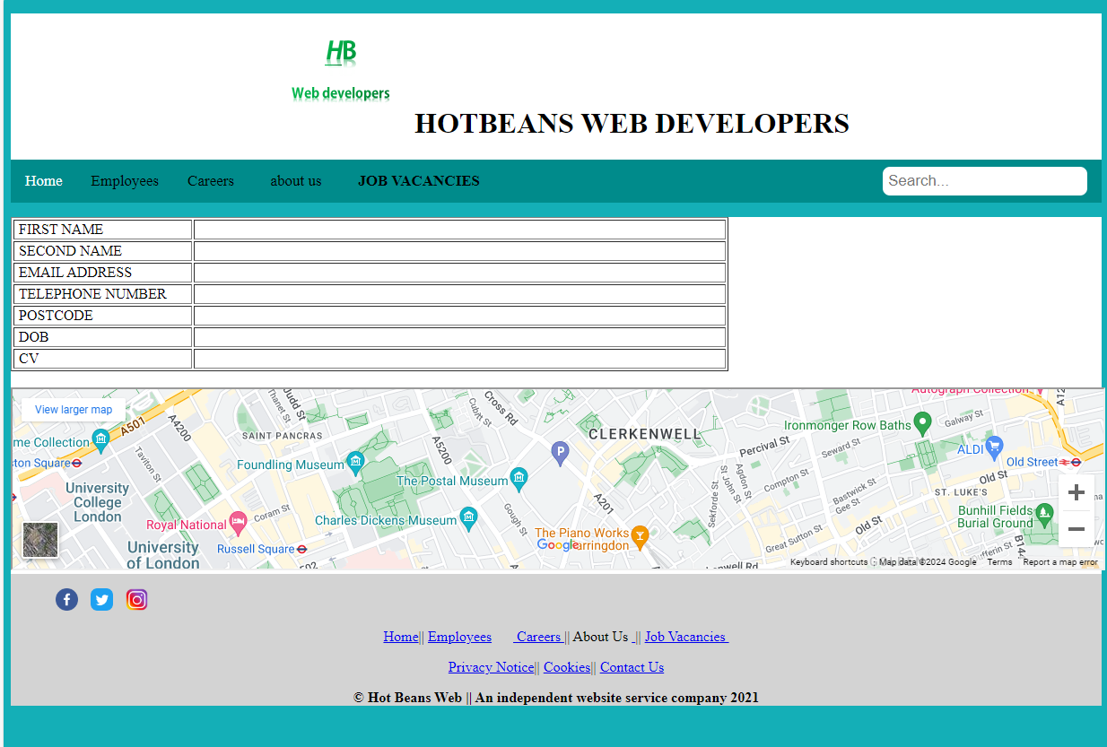

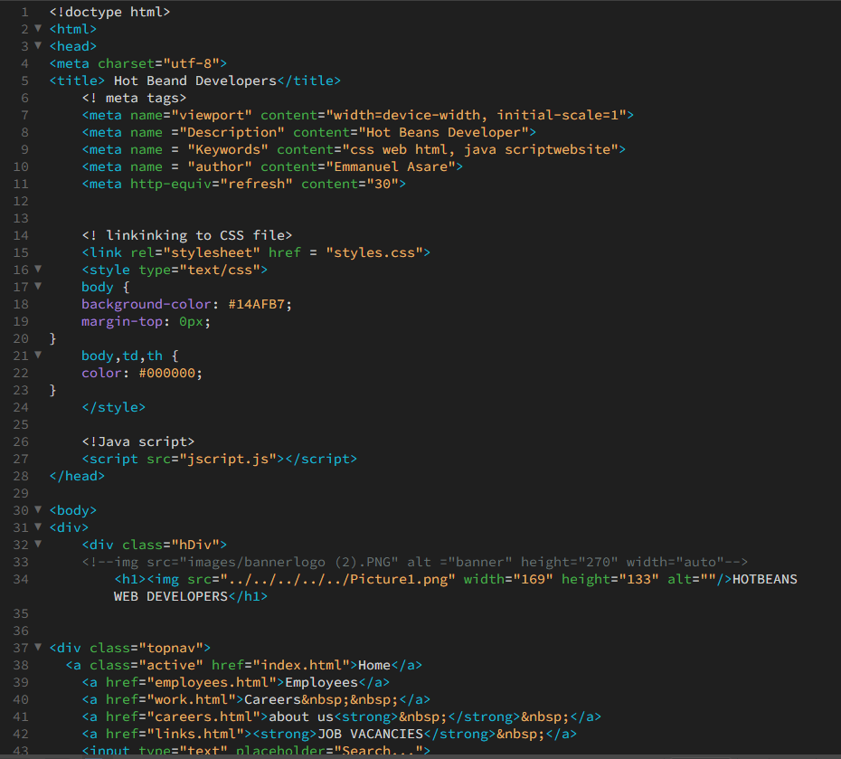

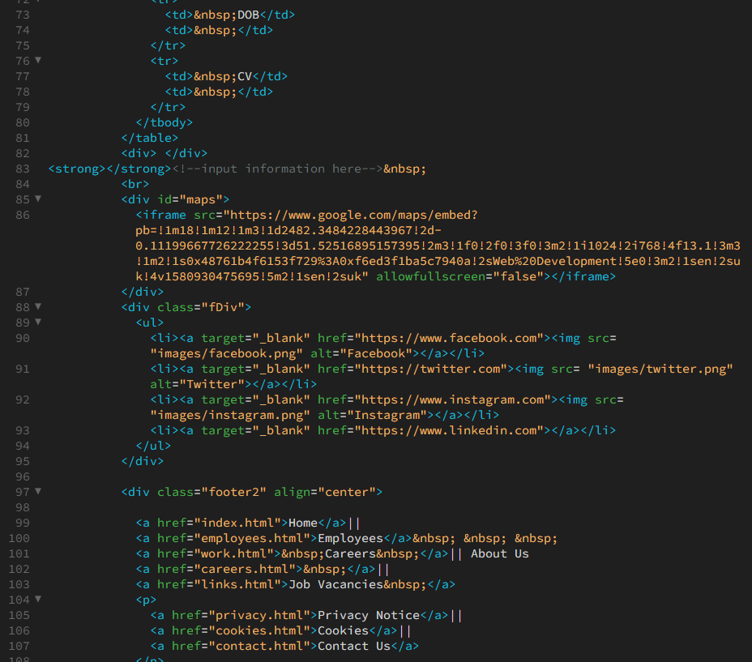

This screenshot shows the application form so users can add in their details to apply for the job. It also shows the code used to create the page.

**Flowchart Diagram and CSS**

Client-side scripting means running scripts, such as JavaScript, on the user’s device. It’s useful as it can interact with webpages and respond to users’ actions without having to connect to a server. This makes it faster to use compared to server-side scripting. I’ve used client-side scripting on all the web pages on my website which provides more interactivity and improves useability on my website. The scripting language I used was adding validation input for the email. This means the user must add in their email to submit the form. If they don’t add in their email when submitting the form, they will be redirected to input their email. I also added a loop so if the data added is incorrect, it will keep asking the user to add correct data. I created a flowchart below which shows the instructions needed to complete the process. I added symbols into my flowchart, such as yes and no, which makes sure all the data is correct and filled. If not, the user will be redirected to add in correct data. It also checks if the email entered matches the user.

start

Display application page

Input email

Input all details

No

Email validation check

Is form completed

no yes

Reset button to reset application

Yes

End

Submit application

**Test Plan (Including images)**

|  |  |  |  |  |  |
| --- | --- | --- | --- | --- | --- |
| **Test no** | **Test description** | **Expected outcome** | **Actual outcome** | **Pass/fail** | **comments** |
| 1 | Test the website on different platforms | I expect the website to work on different browsers |  | pass | The website works on google chrome and Microsoft edge |
| 2 | Test the navigation bar | I expect the navigation bar to work | The navigation bar works successfully | pass | n/a |
| 3 | Test all the images on the website | I expect all the images to load |  | pass | All images load successfully on all web pages |
| 4 | Website performance | I expect the website to work fast with no latency | When clicking on each page, all pages respond quick with no latency | pass | n/a |
| 5 | Test map | I expect the map to load and to be interactive |  | pass | The map loads perfectly and is interactive |

**Website Testing (X3 Web browsers on PC and on Phone)**

Website on Microsoft edge:

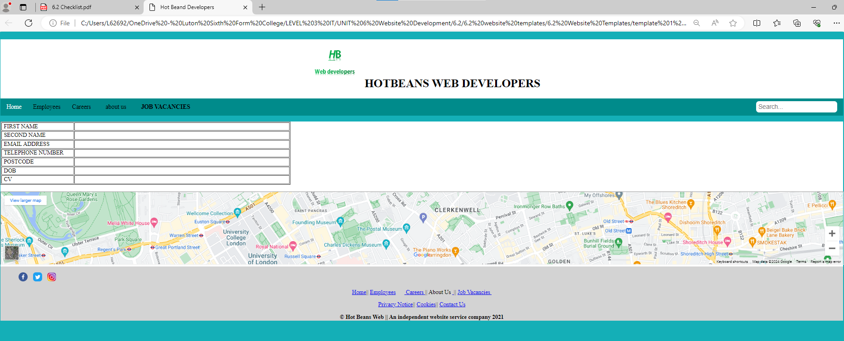

Website on google chrome:

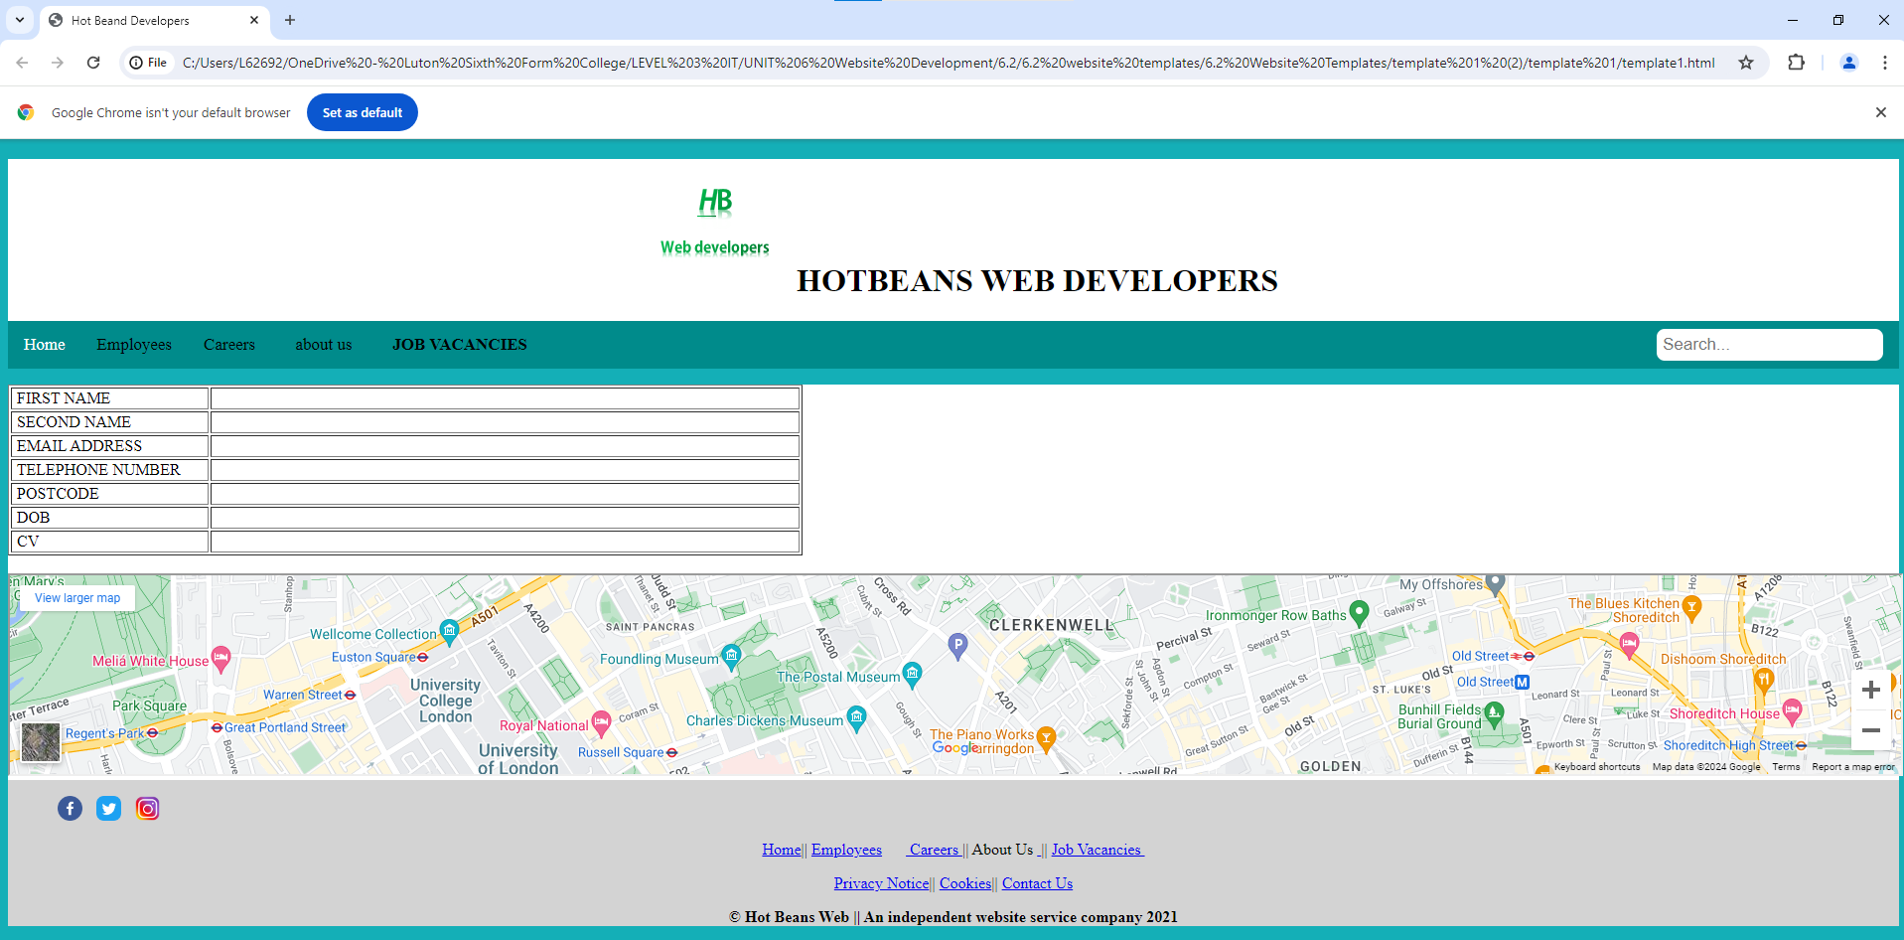

Website on internet explorer:

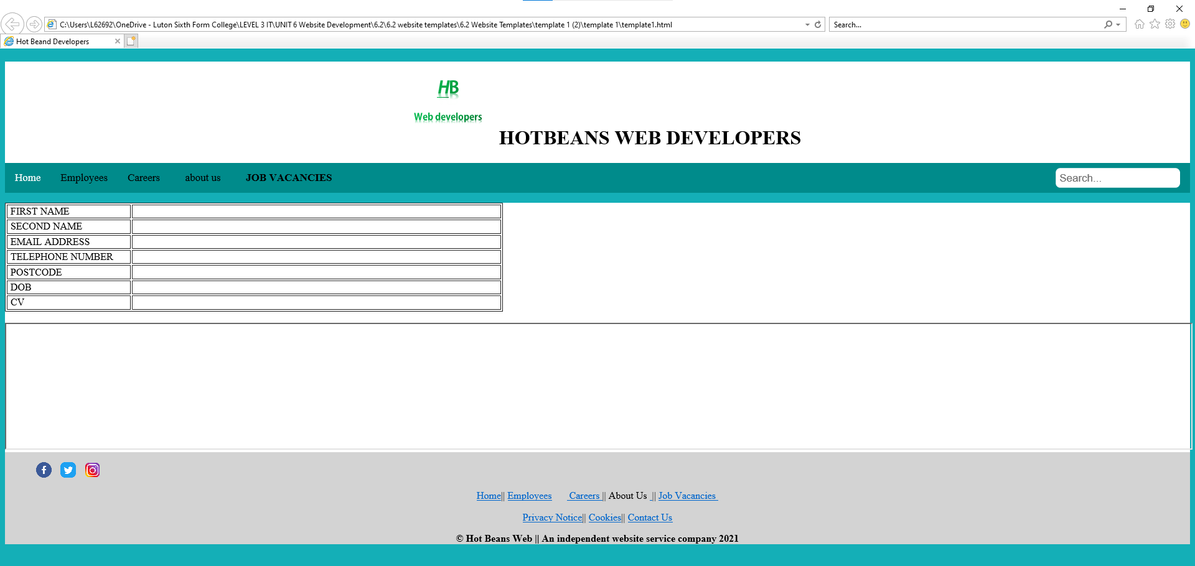

**Website on phone:**

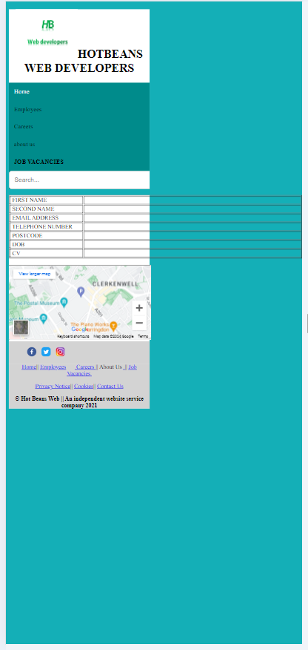

These screenshots show my website working on 3 different browsers and on a mobile device

**Website Questionnaire and feedback**

**Review form:**

1) Do you think Hot Beans Web is a suitable website for new and upcoming web developers?

yes

2) Is it easy to navigate on the website?

yes

3) Do you think the website meets the purpose and suits the target audience?

yes

4) Does the website work correctly on different platforms?

Works on computer devices perfectly however, it's not useable on mobile devices as it doesn't fit correctly.

5) Is the website interactive?

Yes, but the application page needs a submit button.

6) On a scale of 1-10, how would you rate the color scheme and layout of the website? (1 being bad 10 being very good)

7

7) Any other comments?

no

**Website review**

The review form helps me understand what I've done well on my website and what I can improve on. From the review form, the color scheme and layout were rated a 9 out of 10. This means I designed the website well and used the correct color scheme for my website. Furthermore, it shows that my website is interactive and easy to navigate except on mobile devices and on the application page, there’s no submit button. I can optimize this by making sure the website works on mobile devices and fits the size of the screen and adding a submit button to make the application page interactive. From the review form, my website suits the target audience as it targets people who want to become web developers.

**Witness Statement**

**Website optimization Before & After Errors (X3 Design and X2 code changes)**

1. To make the application page more interactive. I have done this by adding a submit button below the form so users can submit their application for the job. This makes the job application page useable for users as they can submit their form.

Before:



After:

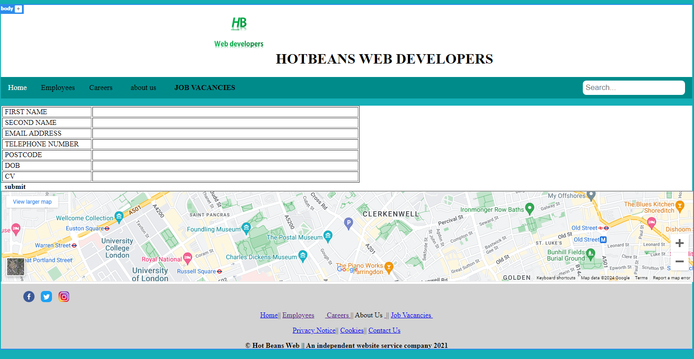

1. Making improvements to the ‘About Us’ page to meet client needs. I’ve optimized the text on the about us page to make it look more presentable and for users to know what Hot Beans Web developers are about.

Before:



After:

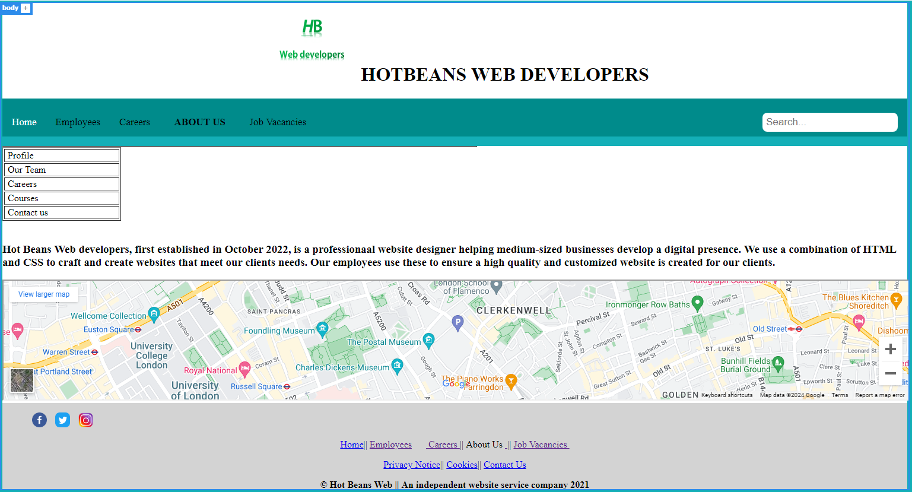

**Evaluate the design and** **optimized websites against client requirements.**

In comparison to the alternative design, the initial design I created fulfils its purpose as it has an aesthetic layout and it’s easy to navigate throughout the website. This makes the website easy to use and understand, which meets the client's requirements. The style I created is original as the navigation buttons are at the top of the page, below the company name. It’s also appropriate for the audience as the style and layout I created looks professional, which fits the purpose of the website. Optimizing my website meant that my website is more interactive as it led me to add a submit button to the application form. It also helped me meet client needs as I added in information on the about us page. From the feedback form, my website is suitable for new and upcoming web developers because the color scheme and layout were rated a 9/10 and it looks professional, its aesthetically pleasing and it’s easy to navigate. Although, my website was interactive, the application form wasn’t interactive because I didn’t add in a submit button. I optimized the application form by adding a submit button, so my website was fully interactive meeting client requirements. I’ve also made sure that when users visit my website, they know what hot beans web is about. To do this, ive added text onto the about us page so users know what the company is about. One strength of my website is that it's easy to navigate for users. This is because I’ve made sure to add the main menus at the top of the page where users can click on them, which takes them to another web page. I’ve created a clear structure and layout when designing the website by making sure the layout is consistent throughout all pages. I’ve done this by using cascading style sheets (CSS) to keep the layout consistent on every web page. This includes the actual design of the website, such as placements of the search bar, menus, information, brand name, logo, and footer. This makes it appealing to the target audience as it’s easy to use, and the website looks professional, making it suitable for users and increasing user retention. Another strength is that my website has fast load times. This is because I’ve used assets with small file types so my website can load faster, which makes my website user friendly. I’ve done this by using bitmap file types on my website such as .gif and .jpeg. In addition, my website is interactive. This is because I’ve added a search bar on every web page so users can easily access the information they are looking for. I’ve also added an application form on my website so users can submit their details when applying for a job. Although I have many strengths on my website, I do have a few weaknesses because my website on mobile hasn’t been optimized, making it unusable for mobile users. The layout doesn’t fit on the screen properly, making the website unusable on mobile devices. This is a disadvantage to mobile users or people who choose to access the website on mobile as they can’t use the website properly which doesn’t meet client requirements.

**Second email to client**

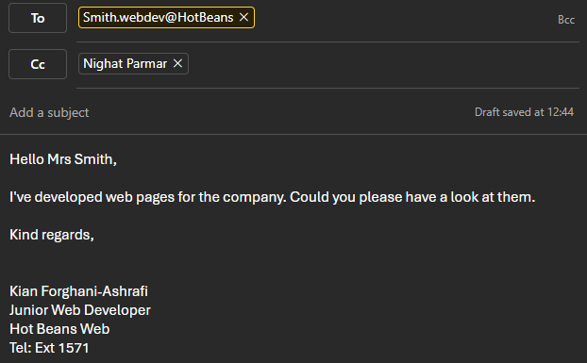

**Project Timeline/Table**

|  |  |  |  |
| --- | --- | --- | --- |
| **Task number** | **Dates** | **Task** | **Achieved/Not achieved** |
| 1 | 27/02/24 | Start date | Achieved |
| 2 | 27/02/24 | Produce a task list | Achieved |
| 3 | 02/03/24 | Produce 2 designs for the client | Achieved |
| 4 | 02/03/24 | Have an interview with the client | Achieved |
| 5 | 10/03/24 | Complete the design stage | Achieved |
| 6 | 10/03/24 | Create a sitemap | Achieved |
| 7 | 14/03/24 | Gather images and text for the website | Achieved |
| 8 | 19/03/24 | Develop homepage | Achieved |
| 9 | 21/03/24 | Develop employee's page | Achieved |
| 10 | 23/03/24 | Develop careers page | Achieved |
| 11 | 24/03/24 | Develop about us page | Achieved |
| 12 | 30/03/24 | Develop job vacancies page and application page | Achieved |
| 13 | 31/03/24 | Create flowchart and CSS | Achieved |
| 14 | 20/04/24 | create test plan | Achieved |
| 15 | 20/04/24 | Test website on different browsers | Achieved |
| 16 | 26/04/24 | Optimize the design | Achieved |
| 17 | 28/04/24 | Carry out website evaluation | Achieved |

The table above (project timeline) shows all the tasks that I’ve completed in this assignment. It shows the beginning stage of each task, how long each task took, the date of each task, and whether the task is achieved or not.

**Evaluation of Website against the Client Requirements**

I’ve used coding and scripting when developing my website on Dreamweaver by creating the design and layout of my website, including assets, using HTML, and cascading style sheets (CSS) on Dreamweaver. CSS allows my website to have a consistent and clear layout on all my web pages. This made it easy to develop each page as each page has the same structure and format. In the development stages of my website, I’ve made sure to make my website interactive by first adding in a search bar at the top right of every page, so users/clients can easily find the information they are looking for. I’ve also created menus at the top of the pages, allowing users to change web pages. I’ve added a submit button onto my website at the optimization stage, allowing users to submit their applications on the application page. In addition, to make my website more interactive, I added in hotspots near the footer of the web page which acts as a hyperlink, so when a user clicks on the social media icons, they are directed to Hot Beans Web social media. All of these makes my website high quality. Furthermore, at the final development of my website, it makes my website useable for all users as they can interact with the website I created and by having a professional layout and look, it's intended to target my target audience. When developing my website, I’ve made sure it’s under the copyright, designs, and patents act 1998. This protects my website and the codes I created as its original. I’ve also made sure my website is protected with the data protection act 1998. This makes sure when users add their personal information on the application form, their personal data is protected. When users click onto the application form, a privacy policy will pop up stating how we will keep their personal data safe. This includes, to not keep personal data longer than necessary, ensure all their personal data is accurate and kept up to date, to not transfer personal data to countries outside the EEA unless there is adequate protection and to take measures against hacking or loss of personal data. I’ve used web consortium standards on my website so it’s accessible to more users. I’ve done this by testing my website on different browsers such as Microsoft edge, google chrome and internet explorer making my website useable to more people. I’ve made my website fully accessible by using HTML compliance when designing my website.

I’ve undertook user testing by making sure my website works on different browsers such as, google chrome, Microsoft edge, internet explorer and mobile devices. I’ve tested my website on these browsers, and it works perfectly and has the same layout. This means my website is accessible to more users as I have used browser compliance on my website. Users can access my website on different browsers and devices, making my website more accessible. I’ve also tested the application form by making sure users can add in their details and can submit their application using the submit button. When I first designed the application form, there was an issue where users weren’t able to submit their application, making the form less interactive and unusable. However, at the optimization stage, I undertook user testing and made sure there’s a submit button for users which allows users to submit their form, improving the user experience.

I used professionalism when developing my website by making sure I understand the client requirements and regularly communicating through emails with the client to get the best out of the planning stages and getting feedback. By getting support from others, it helped me make my website look more professional and to understand the client requirements better. I also used a project timeline which keeps track of all the tasks I’ve completed, including the date I completed the tasks. Another way I used professionalism is when I conducted research to understand the target audience. I done this by using a method called SQIRO. I’ve also made sure my website is under the current legislation which protects users’ personal data and keeps the website I developed original.

I made sure I was up to date with my work by following the project timeline. I completed my work by making sure every task was completed on time. This led me to create a high-quality website. Furthermore, I took accountability of my website design. Although, I had some errors on my website, I took accountability of these errors and used these in the optimization stage which improved my website

Using etiquette is another one of my skills I used which positively affects the outcome of my website. To respect users’ privacy, I’ve made sure we follow data protection laws such as the copyright, designs, and patents act 1998 and the data protection act 1998. These make sure my website is protected and protects users’ personal data. I’ve also added a privacy policy on the application form so users can clearly understand how we hold their personal information and that it is protected. Another way I used etiquette was by using web consortium standards which enabled my website to be accessible to more users. My website also supports users who have visual difficulties by adding screen readers which creates my website to be more accessible.

**Technical Documentation**

The system I used to create my website was Dreamweaver. This allowed me to design and build my website using programming and scripting languages such as CSS, HTML, and JavaScript. By creating my website on Dreamweaver, it’s made my website more interactive and has a more responsive design.

The hardware requirements include the motherboard, Central Processing Unit (CPU), Random Access Memory (RAM), SSD (storage drive), graphics processing unit (GPU), keyboard, mouse, and monitor.

**Bibliography**

Adobe Dreamweaver 2021

References

Appendix 1

Appendix 2